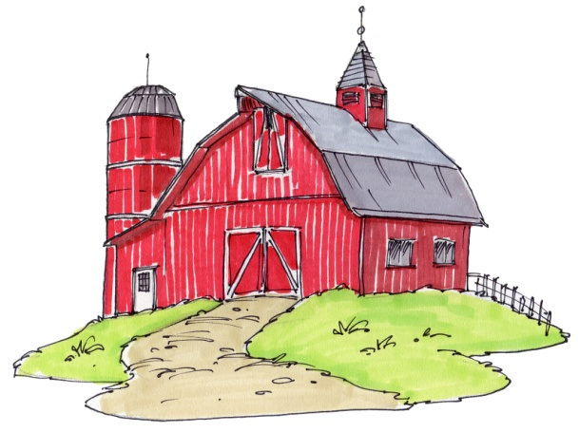
Here’s the answer to May’s Brain Teaser

“What three letter word pronounced one way is a farm animal and pronounced another way is something a farmer does?”
Answer: Sow

